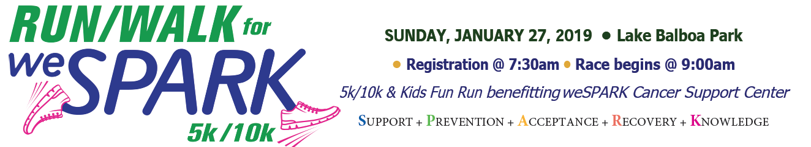
*** MAKE SURE TO PERSONALIZE ANYTHING IN [BRACKETS] ***

Dear [Friend, Family, Donor],

On Sunday, January 27, 2019 I will be participating in the Run/Walk for weSPARK 5k & 10k to raise funds and awareness for weSPARK Cancer Support Center. I am setting a fundraising goal to support this wonderful organization and I need your help!

weSPARK Cancer Support Center provides a wide range of services to cancer patients, their families and friends - completely free of charge. For over 17 years it has been a place where those effected by a cancer diagnosis can join others to share their experience, strength and hope.

I will be participating in the [10K] or [5K] and my personal fundraising goal is $__________. I would truly appreciate contribution you can give to my fundraiser to support this worthwhile cause! Big or small – any amount makes a difference. You can donate to my fundraising page here: (insert fundraising page link OR use the general CrowdRise event page link to have them find your page (LINK HERE)

This is some of what your donation can provide for those whose lives have been affected by cancer:

- $25 pays for one restorative yoga class
- $100 pays for one nutrition workshop
- $250 pays for 5 sessions of the Men’s Support Group
- $500 pays for 5 sessions of the weSPARK Children’s Group
- $1,000 pays for expanding outreach & activities for the teen support group
- $2,500 pays for starting a family support group in Spanish

Thank you for your support! Please consider sharing my fundraising page on your social media platforms for my cause to reach more people.

Gratefully,

[Your Name]

Facebook.com/wesparkcancersupportcenter/
Twitter.com/wesparksupport
Youtube.com/user/wesparksupport
Instagram.com/wesparksupport

